Journal of Oral and Maxillofacial Surgery
Volume 61, Issue 11 , November 2003, Pages 1310-1317

Scientific article

Model surgery with a passive robot arm for orthognathic surgery planning
Tamer Theodossy BDS, MSc, MFDSRCS(Eng) *and Mohammad Anwar Bamber PhD†
* Visiting Specialist Registrar, Oral and Maxillofacial Surgery, University College London Hospitals NHS Trust, London, England, UK
† Senior Maxillofacial Instructor, Eastman Dental Institute, London, England, UK
Available online 27 October 2003.

Abstract
Purpose: The aims of the study were to assess the degree of accuracy of model surgery performed manually using the Eastman technique and to compare it with model surgery performed with the aid of a robot arm.
Patients and Methods: Twenty-one patients undergoing orthognathic surgery gave consent for this study. They were divided into 2 groups based on the model surgery technique used. Group A (52%) had model surgery performed manually, whereas group B (48%) had their model surgery performed using the robot arm. Patients’ maxillary casts were measured before and after model surgery, and results were compared with those for the original treatment plan in horizontal (x-axis), vertical (y-axis), and transverse (z-axis) planes.
Results: Statistical analysis using Mann-Whitney U test for x- and y-axis and independent sample t test for z-axis have shown significant differences between both groups in x-axis (P = .024) and y-axis (P = .01) but not in z-axis (P = .776).
Conclusions: Model surgery performed with the aid of a robot arm is significantly more accurate in anteroposterior and vertical planes than is manual model surgery. Robot arm has an important role to play in orthognathic surgery planning and in determining the biometrics of orthognathic surgical change at the model surgery stage.

Article Outline
• Study aim
• Null hypothesis
• Materials and methods
• Robot arm
• Subject selection criteria
• Occlusal wafers
• Alignment of the robot arm
• Model surgery
• Results
• Acknowledgements
• References

Orthognathic surgery deals with the movement of jaws in cases of facial skeletal deformities and delves around repositioning the maxilla and mandible to correct functional problems and to achieve facial aesthetic balance.
Successful movements in orthognathic surgery require a stable occlusion, which should be decided preoperatively. This requires an accurate facebow registration and transfer to an articulator, followed by accurate model surgery, which anticipates and resolves occlusal problems and predicts the amount of bone removal and addition. Once completed, wafers are constructed that inherently contain information about the treatment plan.
Model surgery represents an important step in orthognathic surgery planning. The models are repositioned intact or sawed along the possible osteotomy lines to determine whether a satisfactory occlusion can be achieved. Where premature cuspal interferences are noted, these are marked on the models, and if necessary, spot grinding is planned. Similarly, extractions of unwanted or overerupted nonfunctional teeth can be carried out.
Model surgery also provides a measure of jaw advancement or setback and bone removal. Splitting and expansion of part or the whole upper arch to accommodate the lower arch may also be planned by this means. When segmental surgery is to be performed, the final "postoperative" planning models are important not only for fabricating the occlusal wafers but also for splints and arch bars.
Conventionally, model surgery has been performed manually, but recent technologic advances have opened up possibilities of using robotic technology.
Robots can be either passive, whereby they are guided at all times by a surgeon, or active, whereby they are monitored rather than controlled by the surgeon.
Robots designed for surgery have 3 main advantages over humans. They have a greater 3-dimensional spatial accuracy and reliability and can achieve much greater precision. Although few surgical robots are currently in clinical trials, 1 or 2 trials have advanced to the stage of seeking approval from the United Kingdom’s Medical Devices Agency and the US Food and Drug Administration. Safety is a key concern. A robotic device can be designed in an intrinsically safe way by restricting its range of movement to a region where it can do no damage. Furthermore, safety can be increased by making it passive, guided at all times by a surgeon. Nevertheless, some of the most promising developments may come from robots that are active (monitored rather than controlled by the surgeon) and not limited to intrinsically safe motion.[1]
The use of a passive robot arm in craniofacial surgery has yet to be explored. Active robot systems, however, have been used in the planning and execution of surgical operation in the craniomaxillofacial region.[2 and 3] Simultaneous planning and execution represent the process of taking implicit task descriptions, planning a sequence of explicit execution commands for robots, and monitoring their execution. As the planning execution process is run completely online during the execution of the assembly task, the planning process is highly reactive, based on sensor information about the robot’s present environment.
A robot arm has been used in the field of neurosurgery for localizing points in 3-dimensional space. Preoperative computed tomography scans are taken for the target region and superimposed onto the bony architecture during the localization of points. The procedure is run completely offline making feedback during the execution virtually impossible.[4]

Study aim
This study was conducted at the Eastman Dental Institute and University College London Hospitals. The aim was to assess and compare the accuracy of model surgery performed manually using the Eastman technique and model surgery performed with the aid of the robot arm.

Null hypothesis
The null hypothesis tested was that there is no difference between manual model surgery using the Eastman technique and model surgery performed using the robot arm.

Materials and methods

Robot arm
The robot arm (FaroArm) is a registered trademark of FARO Technologies, Lake Mary, FL. FaroArm is a highly accurate portable coordinate measurement device designed for engineering, manufacturing, and controlling dimensional quality (Fig 1).

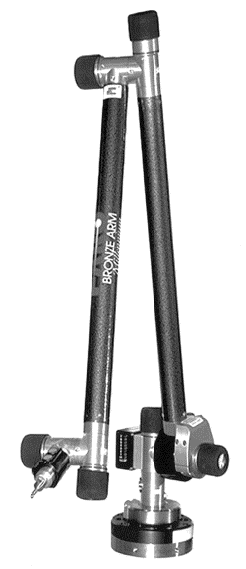
FIGURE 1. Robot arm. Bronze series model.
The bronze series model of the FaroArm delivers guaranteed measurement accuracy as low as ±0.3 mm (±0.012 in). To maintain certified accuracy in a multitude of environments, the monitoring of temperature and the rate of temperature change is required. The FaroArm uses a software/hardware solution in which a semiconductor temperature sensor is built into the device at its point of largest mass. This location is critical because it will be the last to stabilize after any temperature change.
The temperature measured is compared with the reference temperature stored on the on-board EEPROM (electrically erasable programmable read only memory). The difference in temperature is then applied to the mathematical formulas or kinematics, which define the position of the arm in 3-dimensional space. Link length corrections are made constantly by the on-board processor, which adjusts the kinematics and constantly adapts the output to changing environmental temperature. The formulations for the FaroArm are simple because the device is uniformly constructed of aluminium. FARO Technologies proprietary design technology integrates precision encoders to accurately measure the exact position of the probe tip regardless of the user’s approach to the measured part or assembly. Caliper 3D (FARO Technologies) is the basic operating system of the FaroArm. It may be used as a stand-alone 3-dimensional measurement program, or it may be indirectly incorporated into any customized application. It may also be used for calibration verification and to change probes or end effectors.
Points are collected by touching the probe of the articulated arm along the surface of any object and are captured by the touch of 2 buttons on the probe’s pistol-grip handle. Transducers at each of 6 joints combine to report 3-dimensional data, giving the position (x, y, z) and orientation (i, j, k) of points.
A custom-made probe was manufactured (Fig 2). It has a stainless steel square tube that is 3.2 mm in diameter and ends with a sphere that is 3 mm in diameter. The FaroArm’s point of measurement of any ball probe is the center of the ball.
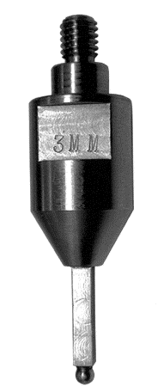
FIGURE 2. Custom-made probe: 3-mm diameter sphere on top of a stainless steel square tube (outer diameter, 3.2 mm).

Subject selection criteria
Twenty-one subjects undergoing orthognathic surgery at the Middlesex and University College London Hospitals were recruited from the joint orthognathic clinic held at the Eastman Dental Hospital. Inclusion criterion was that the patient was undergoing maxillary or bimaxillary procedures. Exclusion criteria were that the patients were undergoing only mandibular procedures, were undergoing maxillary segmental procedures, or were undergoing palatal midline split.

Occlusal wafers
Maxillary impressions were taken for each of the 21 subjects, and occlusal wafers were constructed. The occlusal wafer was manufactured from quick-cure high-impact acrylic for additional strength, and a square stainless steel tube was incorporated into it anteriorly. The internal and external diameters of the tube were 3.2 and 4.0 mm, respectively (Fig 3). This enabled the custom-made probe of the robot arm to fit tightly into the tube when the wafer was in place with the ball end of the probe almost touching the central incisors.
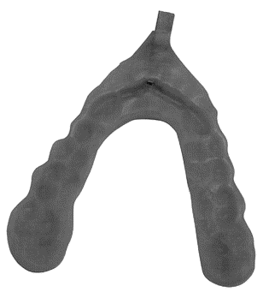
FIGURE 3. Custom-made wafer with stainless steel tube anteriorly.

Alignment of the robot arm
Before any measurement was taken, the robot arm had to be aligned and the 3 axes were defined as follows: 1) The x-axis is defined as the horizontal plane (anteroposterior), 2) The y-axis is defined as the vertical plane (impaction/inferior repositioning), and 3) The z-axis is defined as the transverse plane perpendicular to both the x- and y-axis.
We used the plane/line/point alignment method to align the robot arm, as follows.
1. The plane is defined as the xz plane.
2. The line is defined as the z-axis.
3. The point is defined as the point of origin.
For the plane, 3 points were needed that should form an approximate equilateral triangle, established at the farthest reach on the surface. Ten measurements of each point were taken, which were averaged to define the plane.
For the line, 2 points were needed. The first defines the starting point of the axis, and the second point defines the positive direction of the axis. Again, 10 measurements of each point were taken and were averaged to define the line.
For the point, a single point of origin was needed. Ten measurements of that point were taken, which were averaged to define the point of origin.
All output data were displayed in the coordinate system defined in Figure 4.
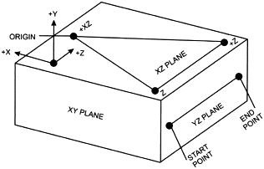
FIGURE 4. Plane/line/point alignment defining the axes and point of origin.

The first step was to assess how accurate the robot arm would be in relocating a point in space. Initial research was carried out on the use of the passive robot arm to assess its accuracy in localizing defined points in space.[5] This was done by analyzing 5 maxillary osteotomy cases and measuring the error in the maxillary cast position in 3-dimensional space. Results showed that a passive robot arm provided repeatable and more accurate results within 1 m³ working space than the digital calliper and has greater potential for use in orthognathic surgery planning.
The accuracy was further tested by securely mounting 2 pieces of impression compound material (Kerr, Los Angeles, CA) on the wall. The first piece had 3 locating points placed in an equilateral triangle arrangement. These 3-mm-diameter locating points were made with the probe of the robot arm while the material was still soft and used to align the robot arm as previously described, thus defining the axes and the point of origin.
The second piece had a single locating point that was also made with the probe of the robot arm and was the point to be measured.
Sixteen sets of measurements were generated. Deducting the distance between the location of the measured point and the point of origin provides the exact location of the point in 3 dimensions in relation to the frame of alignment.

Model surgery
The 21 patients consented for the study were randomized into 2 groups for maxillary model surgery. Group A consisted of 11 patients (52%) who underwent manual model surgery. Group B consisted of 10 patients (48%) who underwent model surgery with the aid of the robot arm.
Manual model surgery (group A) was performed using the usual Eastman technique by one operator (A.B.) to eliminate any interoperator difference. A semiadjustable articulator was used to mount the upper and lower models using a face-bow recording and occlusal records. This orientates the models to the Frankfurt plane; thereby, the orbital pin of the face-bow makes the upper mounting plate of the articulator the equivalent of the inferior orbital margin. Horizontal and vertical reference lines are drawn on the mounting plaster to register the position of each maxillary segment before surgery. Osteotomy lines are drawn to correspond with the bone cuts. The plaster mounting assembly is then sectioned at the osteotomy sites with a saw or large abrasive disc, and the whole arch or segments are repositioned in the planned postoperative position and fixed with hard modeling or sticky wax to secure the mobilized segments in their new position.[6]
Group B model surgery was performed by one operator (T.T.) with the aid of the passive robot arm. The upper member of the articulator was securely mounted on the wall (Fig 5). Three holes were drilled on the articulator using a 3-mm round bur for the purpose of aligning the robot arm. Nine holes were drilled in the maxillary models as follows (Fig 6):
1. Three holes were made, 2 on the left side and 1 on the right side, above the A-line on the model so that they will not be affected when models are cut. These are used to verify that the base of the model is correctly seated in its position on the articulator.
2. Six holes were made, 3 on each side between the teeth and the B-line, so that they move with the sectioned part of the maxillary model. They were located above the last molar, the second premolar, and the lateral incisor. These are used for estimating the amount of movement achieved in all 3 dimensions all around the model.

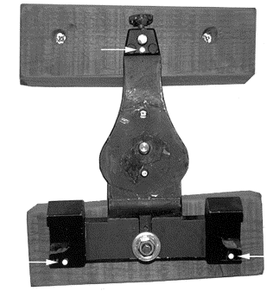
FIGURE 5. Mounted upper member of articulator. Arrows showing points used for alignment of the robot arm.
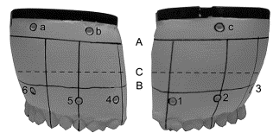
FIGURE 6. Right and left view of models showing A-line (A), B-line (B), and osteotomy cut (C). Points a, b, and c above A-line. Points 1, 2, 3, 4, 5, and 6 used for measurement of the position of the model.
A custom-made wafer for each of the patients with the square tube incorporated at the front was used to determine the amount of movement at the incisor region.
The maxillary models, in both groups, were measured before model surgery using the robot arm by mounting them on the articulator and measuring them 4 separate times at 5-minute intervals and with the robot arm realigned each time. The models were removed from the articulator and placed back after the second set of measurements so as to confirm that the models take the same position each time they are mounted on the articulator, and this was confirmed by the readings generated from the 3 points above the A-line. On the first and fourth alignment, 1,100 readings were generated, and they correspond to 100 readings for each of the following points:
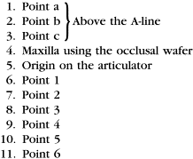
On the second and third alignment, 500 readings were generated, and they correspond to 100 readings for each of the following points:
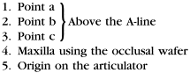
The mean of each 100 readings for each point was calculated. These means were fed into a custom-made Microsoft Excel worksheet.
Points a, b, and c were compared with each other to see whether the models took the same position each time they were mounted on the articulator.
Maxilla and origin points were deducted from each other in each alignment to give the position of the maxilla in relation to the articulator; then the 4 positions generated from the 4 attempts were averaged together to give a single reading of the maxillary position.
Points 1 to 6 from alignment 1 were averaged with their correspondent in alignment 4 to give a single reading of each point.
In group A, once models were fixed to their new position according to the surgical treatment plan, the models were remeasured using the robot arm, and the same points were generated after model surgery and input into the Excel worksheet.
In group B, the pre-model surgery measurements of the maxilla at the central incisor position using the occlusal wafer and points 1 to 6 were input into the Build option (Fig 7) of Caliper 3D software after being adjusted according to the clinical treatment plan using Table 1.
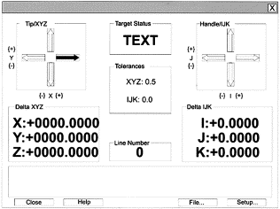
FIGURE 7. Build screen dialog box. Caliper 3D software. Arrows go blank if the model is in the correct position in 3 dimensions.
Table 1. ADD OR SUBTRACT THE AMOUNT OF MOVEMENT IN EACH DIRECTION
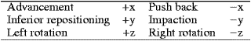
The tolerance level was set to 0.5 mm on the software. The models were cut and secured loosely using red beading wax. The robot arm was aligned and, using the occlusal wafer with the probe of the robot arm in situ, the models were moved until the screen readings showed that the incisors were in the planned position. The process was repeated for the posterior positions using the adjusted points 1 to 6. Once all 6 points together with the incisor location were judged to be in the planned position, the model was secured in the new position using sticky wax. After model surgery, the models were then remeasured using the robot arm and errors were calculated.
In cases of differential impaction, a point was marked in the palate on a line connecting the most posterior right and left molars (Fig 8, arrow 1). Using the robot arm, the distance between that point and the labial surface of the central incisors (arrow 2) was calculated using the Measure menu, which measured the shortest linear distance between these 2 points. This figure was used as the new probe length. When doing the differential posterior impaction using the robot arm, in addition to measuring the most posterior adjusted points 1 and 4 to judge the impaction at the back, the probe length is increased by the planned figure of impaction, thus enabling the robot arm, using the occlusal wafer, to read at the back of the palate rather than the front; thus, the differential impaction was measured.
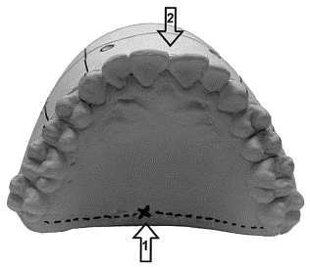
FIGURE 8. Distance measured for posterior impaction between point connecting the last molar on each side (arrow 1) and labial surface of central incisor (arrow 2).

Results
Results obtained from assessing the accuracy of the robot arm using the 16 sets of measurements generated the following error means:
Mean error in the x-axis was 0.24 ± 0.07 mm
Mean error in the y-axis was 0.07 ± 0.03 mm
Mean error in the z-axis was 0.20 ± 0.06 mm
The numbers generated from the pre- and post-model surgery measurements in both groups A and B were input into an Excel worksheet. The difference between them represented the amount of movement achieved on the models. This was compared with the amount of movement planned.
Results of maxillary model surgery using either the manual technique or the robot arm are presented in Figure 9, which compares both the planned and achieved results in each of these techniques.
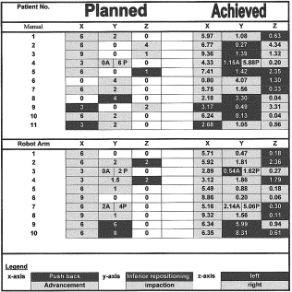
FIGURE 9. Results of maxillary model surgery using either the manual or the robot arm technique.
The movements in each axis are color-coded for ease of reference. The dark shade represents a push-back, inferior repositioning, and left rotation in the x-, y-, and z-axis, respectively, and the light shade represents advancement, impaction, and right rotation in the x-, y-, and z-axis, respectively.
In cases of differential impaction, the anterior movement is referred to as A and the posterior as P.
Statistical analysis was conducted on these figures to see whether there was any statistical significance between both groups. The x-axis and y-axis were subjected to the Mann-Whitney U test because their distribution was skewed when plotted. As for the z-axis, it was subjected to an independent sample t test because it followed a normal distribution when plotted.
Results showed that there was statistically significant error in the x-axis (P = .024) and the y-axis (P = .01), but not in the z-axis (P = .776). Thus, the null hypothesis was rejected for the x- and y-axis, but not the z-axis, indicating that there was a significant difference between both techniques. By plotting the means of the differences between the achieved and planned results using both techniques in all 3 axes, we were able to show that model surgery performed with aid of a passive robot arm was significantly more accurate than the manual technique (Fig 10).
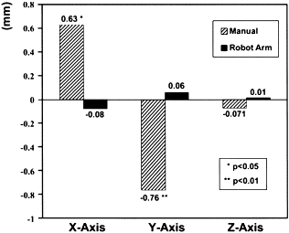
FIGURE 10. Means of differences between planned and achieved movements using manual and robot arm technique. *P < .05, **P < .01.
Results obtained from testing the accuracy of the robot arm confirmed the results of the initial research.[5] The accuracy of the device can be guaranteed up to 0.2 mm, which is what is claimed by the manufacturing company.
This study showed that model surgery performed with the aid of a robot arm was significantly more accurate than model surgery performed manually in antero-posterior and vertical planes. In the manual technique, there was a tendency to overachieve the planned movement in the anteroposterior plane (x-axis), and this mainly translated to overadvancements, as 82% (9 of 11) of the cases were advancements. There also was a tendency to overachieve in the transverse plane (z-axis). As for the vertical plane (y-axis), there was a tendency to underachieve, and this translated to a reduced amount of impaction, as 91% (10 of 11) of these cases were impactions. These tendencies were not detected in the robot arm group.
Although the errors in the manual model surgery were small, but because the model surgery stage represents the first stage in a chain of procedures leading up to an ultimate result, these errors should be avoided, which is where this new robot arm fits into the equation, providing us with more accurate model surgery.
A literature search using the PubMed database and MEDLINE with the search strategies of "orthognathic surgery" combined with "robotics" has failed to show any previous studies. This study represents the first of its kind in trying to use such a device in orthognathic surgery planning. We accept that, at the moment, it is clinically impractical to accept the degree of accuracy generated by the robot arm, which is expressed to the second decimal place.
This has been a fruitful study of the role of a passive robot arm in determining the biometrics of orthognathic surgical changes at the model surgery stage. The next phase is the use of the robot arm on surgical patients preoperatively and postoperatively and, if successful, devising a way to introduce it to the operating room to aid in the localization of points during orthognathic procedures.

Acknowledgements
The authors would like to thank Samir Nassar for his help in preparing the illustrations and the photographs, Samer Theodossy for his help in deriving the mathematical formulas, and Robin Richards and Alf Linney for their help with the Robot Arm.

References
1. R.A. Buckingham and R.O. Buckingham, Robots in operating theatres. Br Med J 311 (1995), p. 1479. Abstract-EMBASE | Abstract-MEDLINE
2. P. Pokrandt, P. Bohner, J.P. Lenolle et al., A communication system supporting simultaneous planning and execution in craniomaxillofacial surgery. J Telemed Telecare 1 (1996), p. 3. Abstract-MEDLINE | Full Text via CrossRef
3. P. Bohner, C. Holler and S. Hassfeld, Operation planning in craniomaxillofacial surgery. Comput Aided Surg 2 (1997), p. 153. Abstract-EMBASE | Abstract-MEDLINE | Full Text via CrossRef
4. U. Spetzger, J.M. Gilsbach, R. Mosges et al., The computer-assisted localizer, a navigational help in microneurosurgery. Eur Surg Res 29 (1997), p. 482.
5. M.A. Bamber, P. Chios, A.C. Tan et al., Reproducibility of a point in 3D space and model surgery measurements using a passive robot arm probe. J Dent Res 78 (1999), p. 1050.
6. M. Anwar and M. Harris, Model surgery for orthognathic planning. Br J Oral Maxillofac Surg 28 (1990), p. 393. Abstract
Corresponding author. Address correspondence and reprint requests to Dr Theodossy: Maxillofacial Unit, UCLH, Mortimer Market, , London, WC1E 6AU, , UK mailto=tamertheodossy@hotmail.com

