Instituto Superior de Ciencias Médicas de Villa Clara

Dr. Serafín Ruiz de Zárate Ruiz

Material de apoyo para el tratamiento de la comprensión de la lectura en la clase de Inglés

Autores: Lic. Nuris Pérez Martínez
Msc Lissette Martínez Menéndez
Lic. Bárbara Teutor Rodríguez

Introducción

La lectura constituye un instrumento de acceso al conocimiento, a la actualización científica, además de ser un medio autodidáctico que posibilita la formación del ser humano.

La estructuración del trabajo que ponemos en sus manos consiste en la recopilación de textos auténticos, gradados, que pueden ser usados en todos los años del ciclo de Inglés General y otra serie de textos médicos que podrán ser usados en el 4to y 5to años de la carrera de Medicina. En la confección del material tuvimos en cuenta las necesidades e intereses de nuestros estudiantes para tributar a su perfil de salida.

La necesidad de nuestros profesionales de una actualización constante en la búsqueda de información científica y la carencia de materiales docentes para ejercitar en la clase la habilidad de comprensión de lectura no s motivó a la realización de este material, que esperamos sea de gran utilidad para ustedes.

Los autores.

LIMITED SURGERY FOR GASTRIC CANCER
( taken from The Lancet Oncology Vol. 4 2003)

The proportion of gastric cancer that is detected at an early stage has increased during the past few years. Early stage gastric cancer now accounts for more than half of all cases. Furthermore, as the population ages, the number of patients older than 70 who present with gastric cancer has also gone up, this contributes to an increase in evidence of complications.
As a result of these trends, treatment approaches commonly used for early stage cancer have diversified. Advances in procedures for endoscopic mucosal resection and development of new instruments for laparoscopic surgery in recent years have results in an increase in the range and complexity of methods for treating early stage gastric cancer. Although gastrectomy plus dissection of second-echelon lymph nodes has been established as a standard surgery for mid-stage cancer, there is controversy about which method is most appropriate for treating very early and far advanced disease. The existence of diverse treatment options has resulted in wide variations in treatment selection criteria between institutions and among individual surgeons. The definition of conventional surgical treatment encompasses resection of at least two thirds of the stomach and dissection of first and second level lymph nodes. Thus, the term limited surgery is applied to any technique in which dissection is less intensive. At present, dissection of second level lymph nodes is generally considered appropriate, but extending to dissection third-third level nodes is still considered experimental. Thus, a basic requirement for all gastric cancer surgeons is that they are able to dissect second level lymph nodes.

ACTIVITIES:

- Read the text to select the correct alternative or alternatives.

  - Choices for the most appropriate technique include:
_____consideration of the stage of the cancer.
_____patients´ age and history.
_____ the number of patients affected

  - Aging process of the population brings about:
_____an increase in wide variations of treatment selection criteria
_____ an increased number of patients affected suffering from gastric cancer
______an increase in the range of methods for treating gastric cancer

  - The term limited surgery accounts for:
_____ conventional surgery
_____ less extensive dissection
_____ extended dissection

  - Treatment approaches for early stage cancer have diversified because:

_____ many people have died recently
_____ the proportion of gastric cancer has increased recently.
_____ the population has been aging

5. Conventional therapy includes:
_____ dissection of second level lymph nodes alone
_____ extended dissection to include third level lymph nodes
_____ resection of two thirds of the stomach and dissection of firth and second level lymph nodes.

- Answer the following questions according to the reading
  - What is the consequence of population aging concerning gastric cancer?
  - Why have treatment approaches diversified recently?
  - Explain what is said about the most appropriate method to treat very early and far advanced disease.
  - Under which conditions the variants may be used?
  - What is your own opinion about it? What is the treatment used for gastric cancer in your country?

III. De scribe the following flow chart with your own words, you should take into account the information from the reading passage

GASTRIC CANCER
STAGES
DIAGNOSIS
TREATMENT
Conventional
limited
standard

DIAGNOSIS OF PERINATAL TURBERCULOSIS

(taken from The Lancet Infectious Diseases. Vol. 4 (3) 2004)

- Skim the article to complete the missing information.

- Babies at risk for perinatal TB are ________________________.
- Diagnosis is confirmed by ______________________________.
- Missed diagnosis may _________________________________.
- Tuberculine skin testing in neonates is ___________ because of
___________.
- As tuberculosis develops ______________both should be ______.
Of M. tuberculosis , which may take up
- Common differential diagnosis includes ______________.
- Delayed diagnosis may be accounted for ____________________.

Babies at risk of perinatal tuberculosis includes those whose mothers have proven or suspected tuberculosis disease during pregnancy. Failure to investigate appropriately may result in a missed diagnosis and contribute to mortality especially as signs of disease may not appear until several days or weeks later if the infection is transmitted peripartum rather than intrauterine.Confirmation of diagnosis is based on the detection of acid-fast bacilli on a smear microscopy and/ or culture of Micobacterium tuberculosis from neonatal samples or histology.
Delays in diagnosis of smear negative culture positive congenital tuberculosis, may be accounted for by the slow growth of M.Tuberculosis, which take up to 12 weeks.The use of tuberculina skin testing in the neonatal period is incredible since most babies due to their immunological inmmaturity,will amount a delayed hypersensitivity with response ,even if infected at this stage.In HIV-1- infected symptomatic newborn babies and infants, the effect of CD4 suppression on the cellular immune response to TB antigen is unknown.Since tuberculosis develops slowly and it`s possible for the recently infected baby to appear well early on both the apparently well baby and the symptomatic,common diferential diagnoses for each clinical signs elicited should be treated accordingly.These includes congenital syphilis, congenital cytomegalovirus, congenital herpes virus infection.Tuberculosis as a differential diagnosis or a copathology 19 often to exclude in these circumstances and antituberculosis therapy is often started on suspicion.

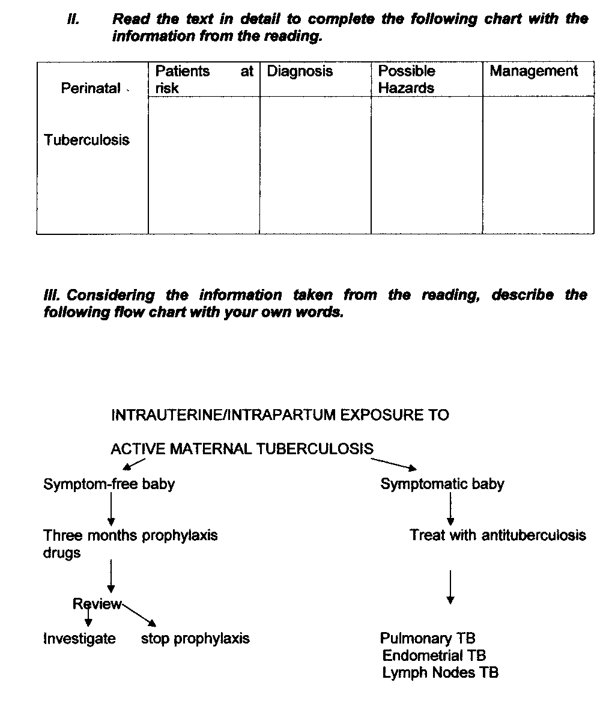

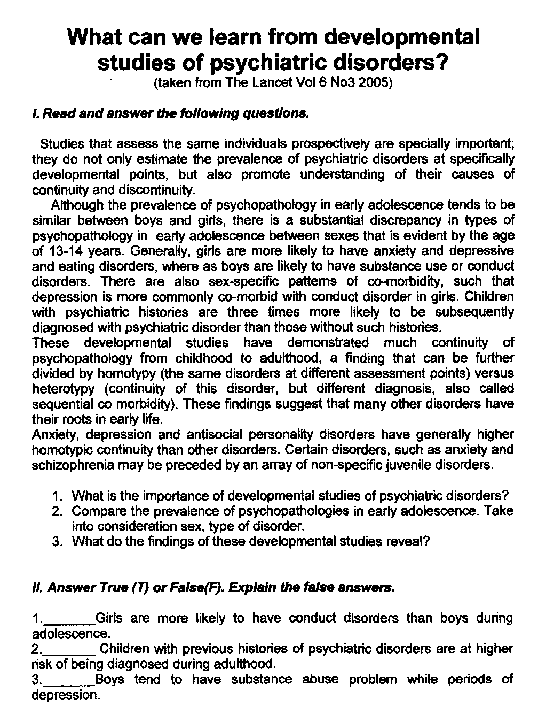

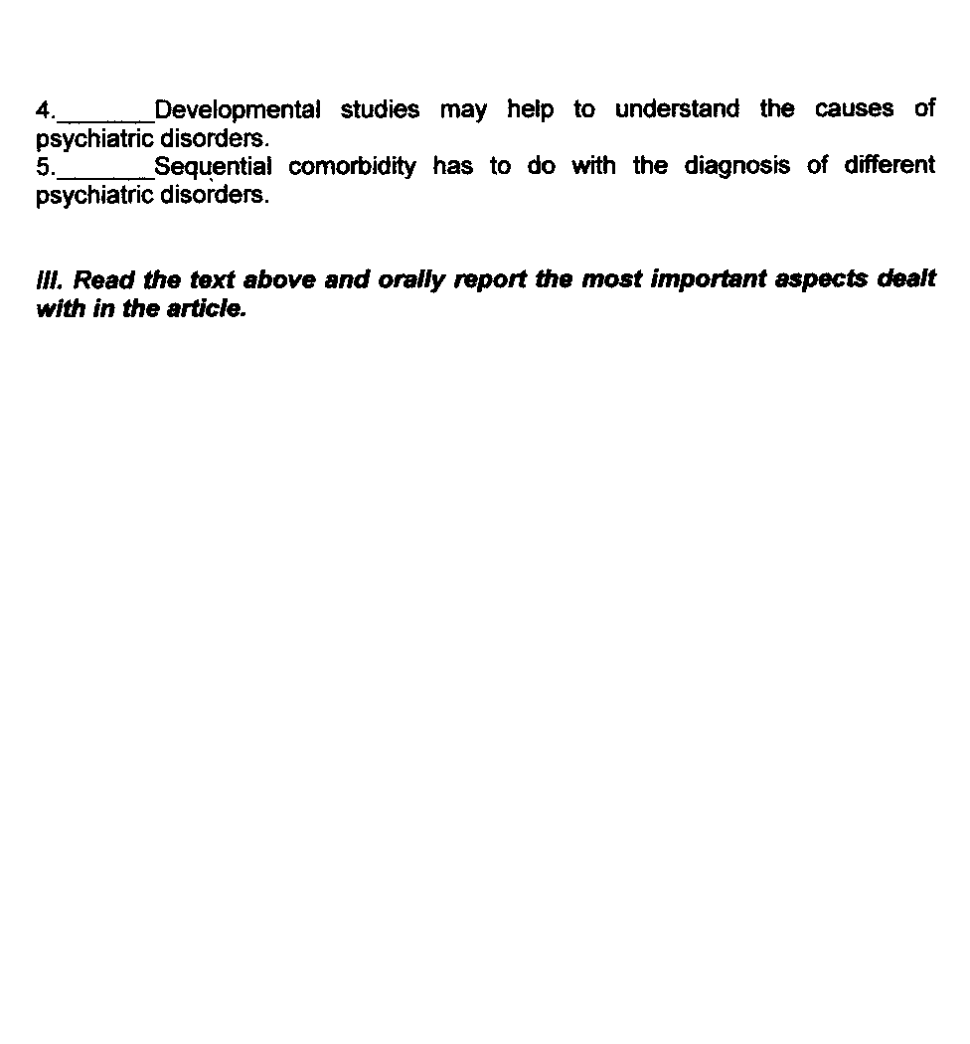

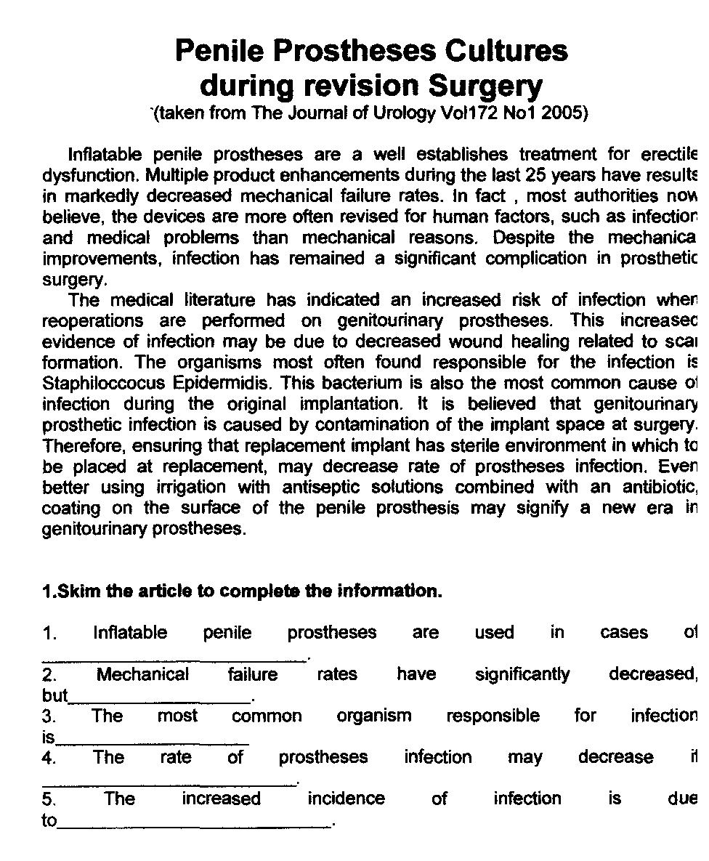

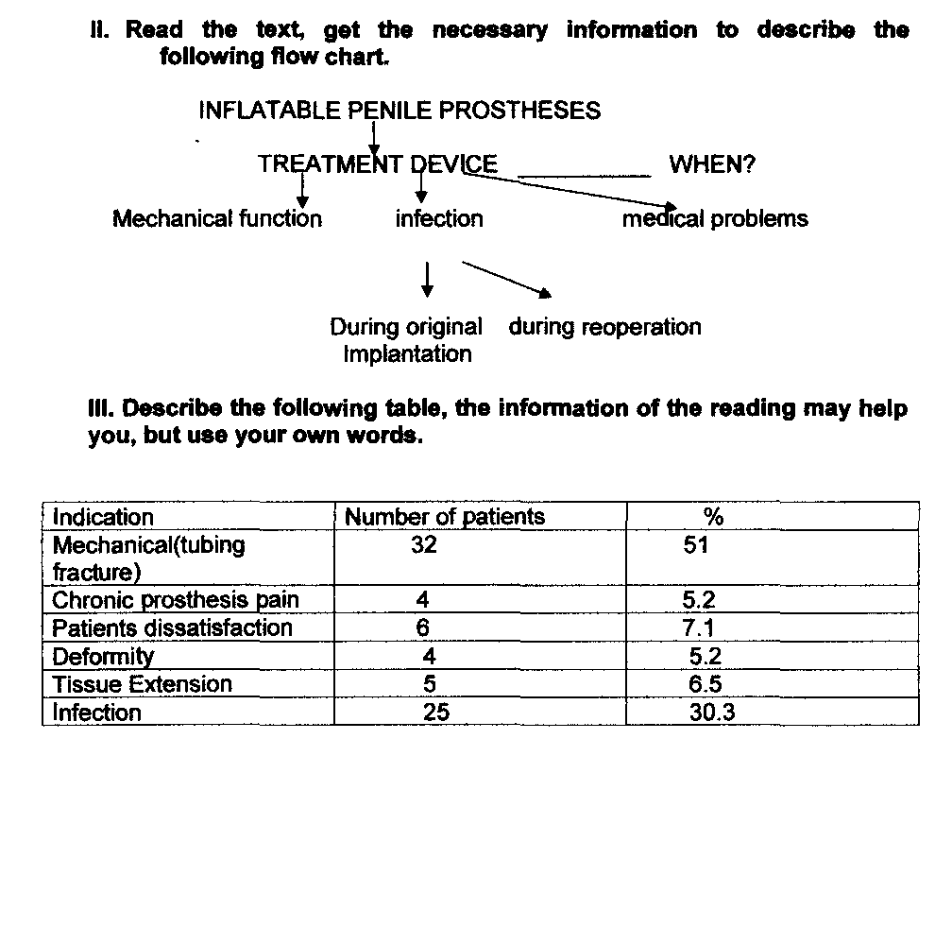

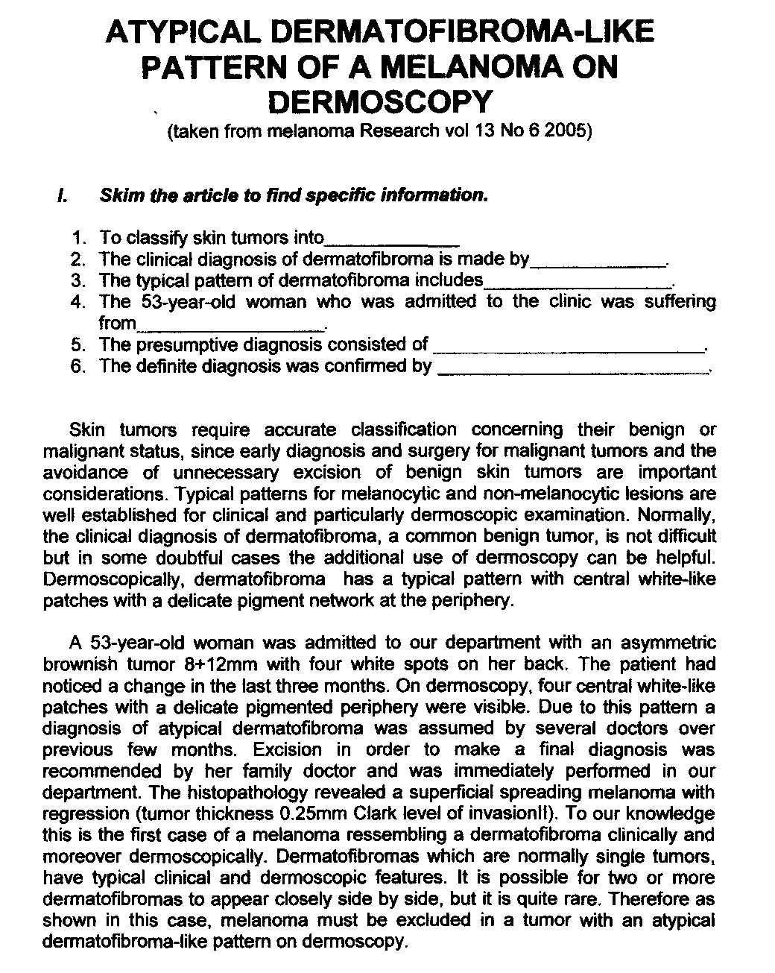

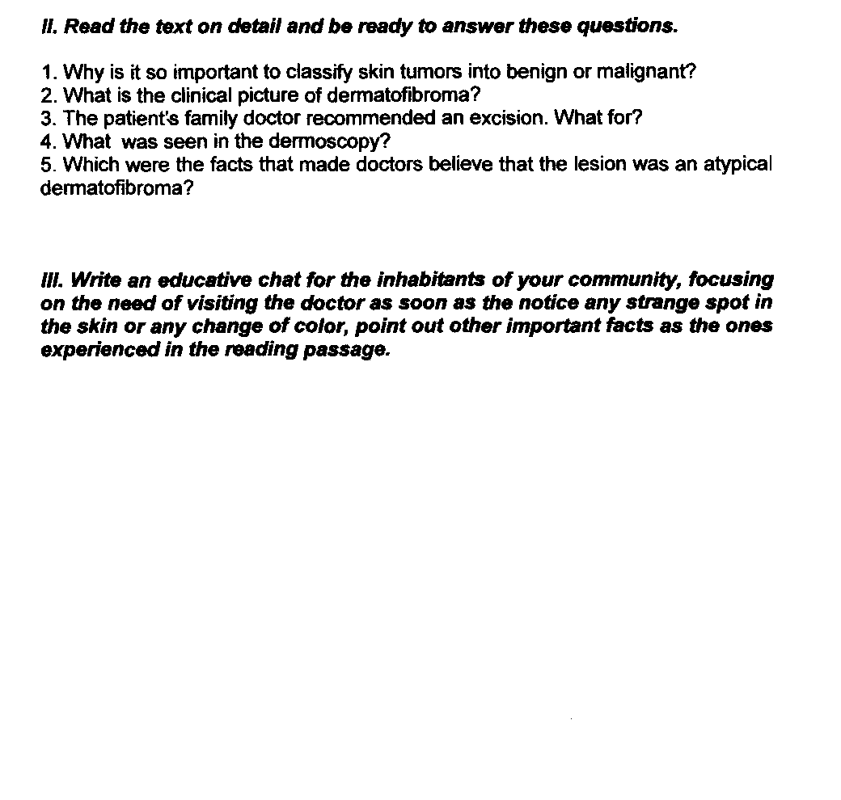

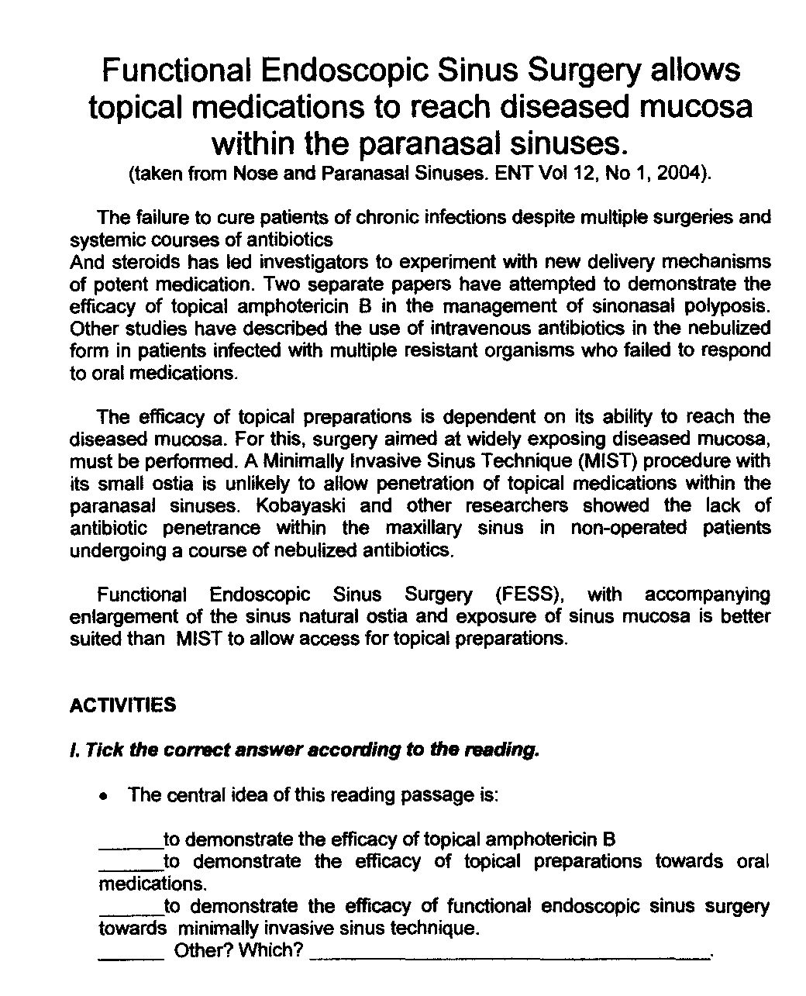

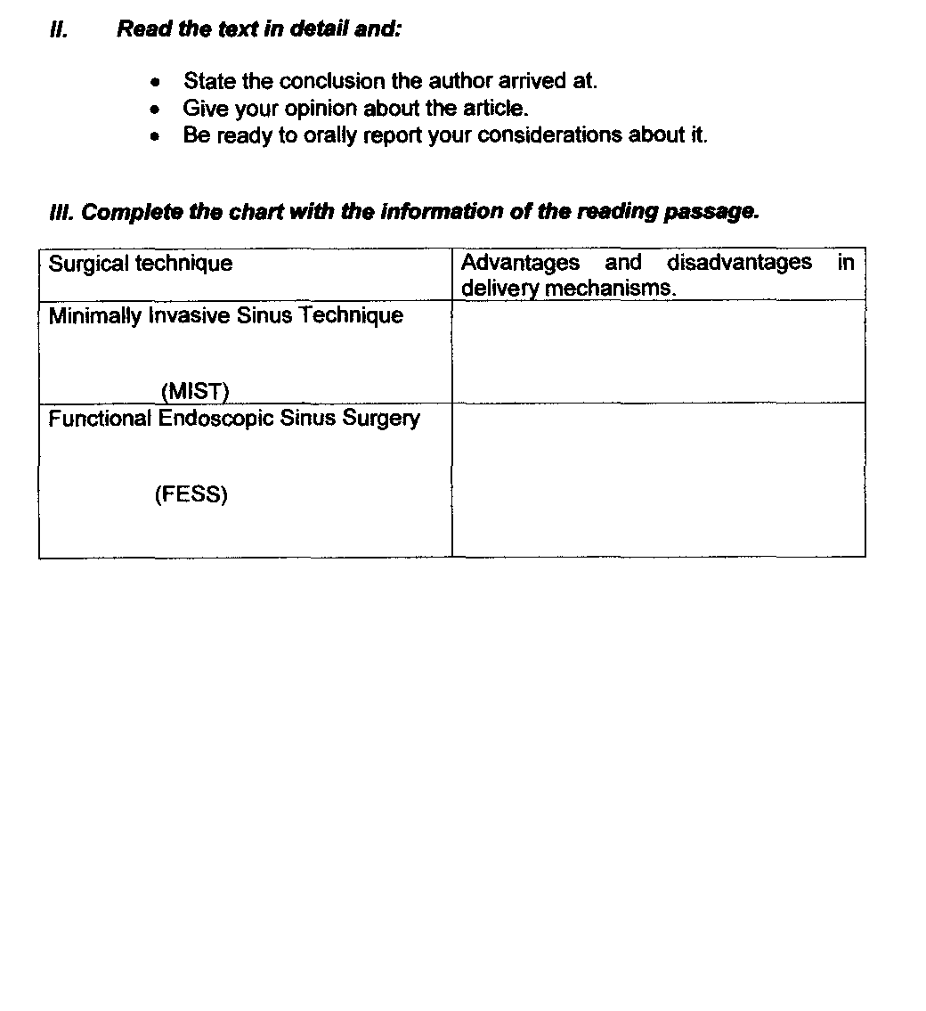

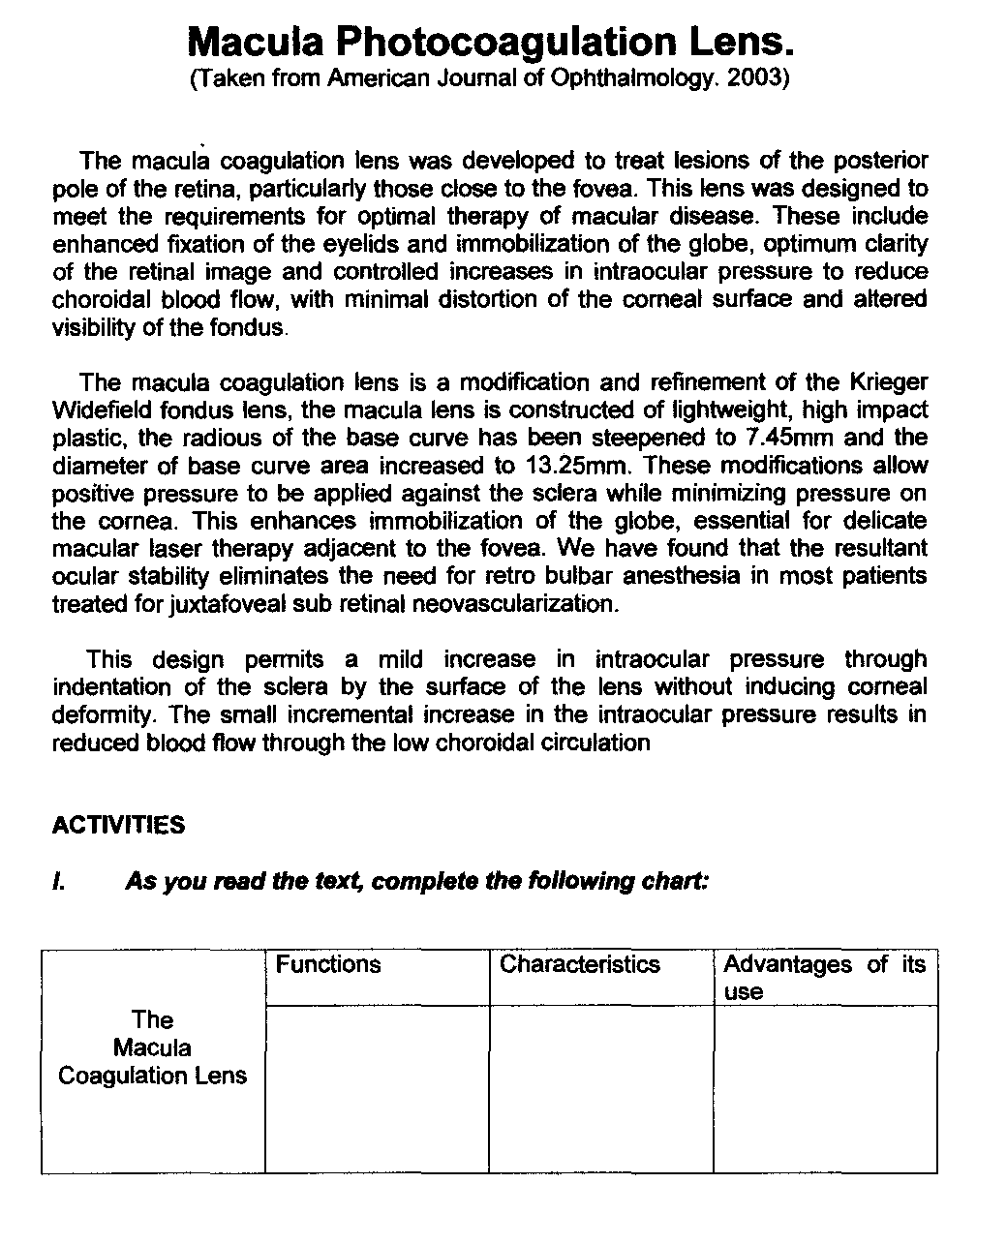

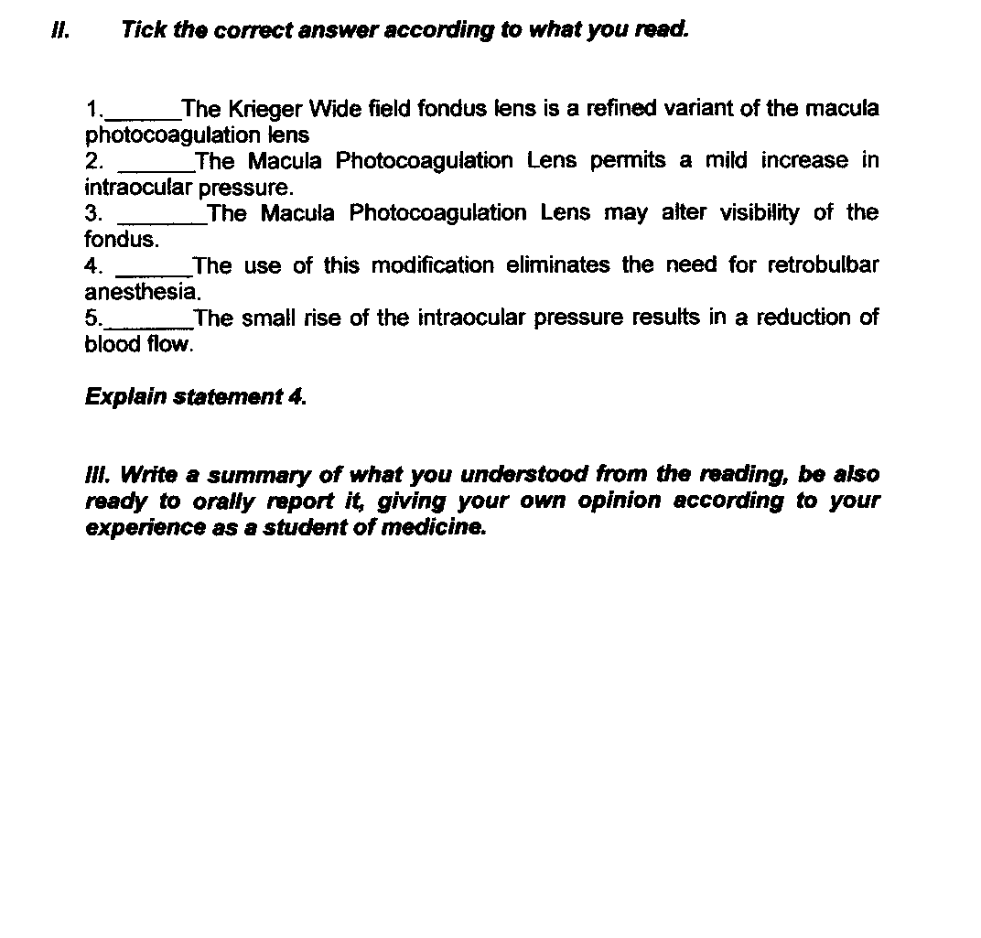

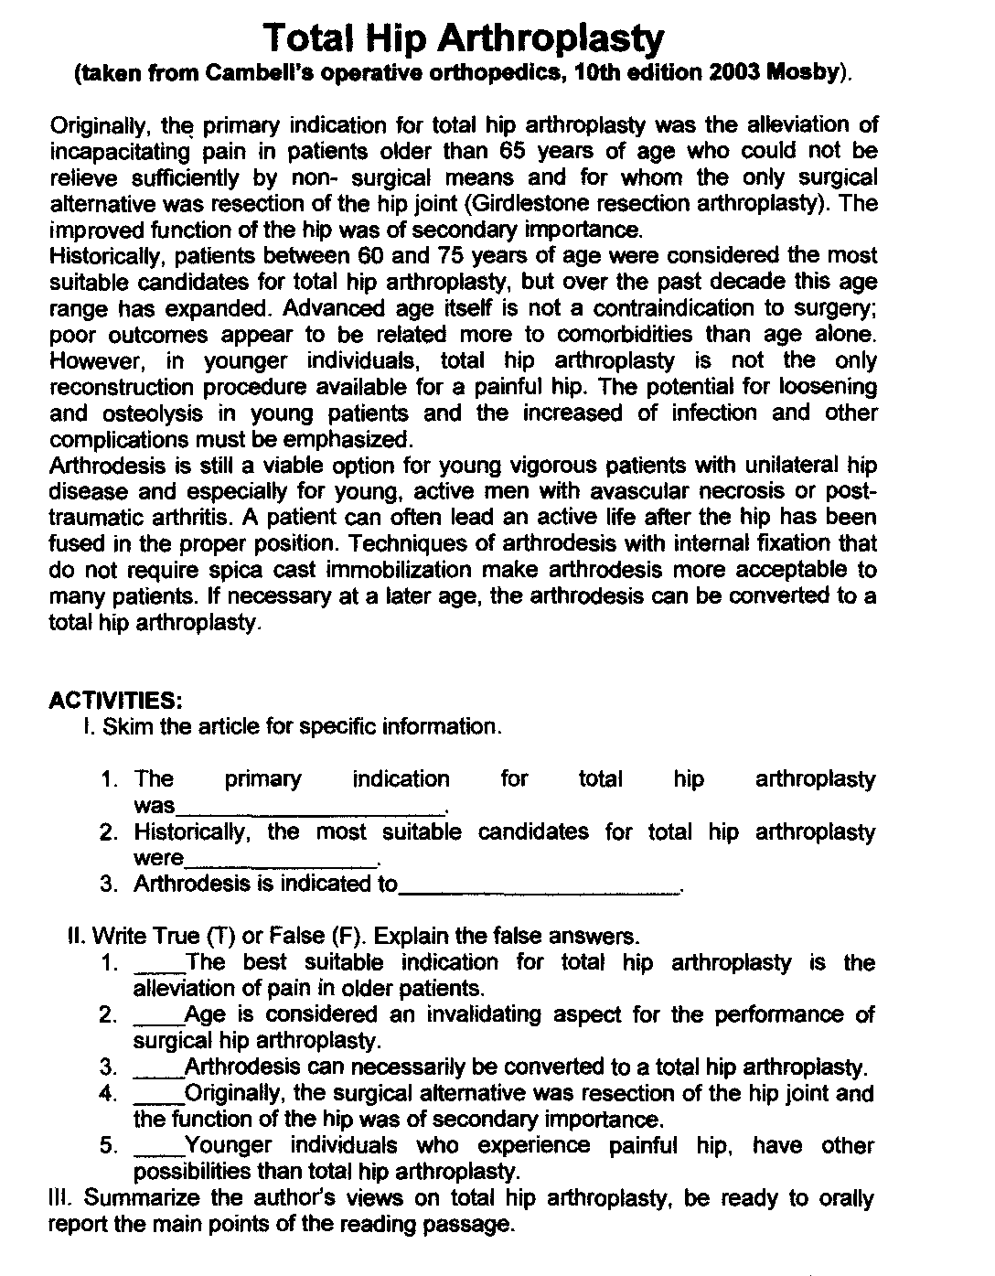

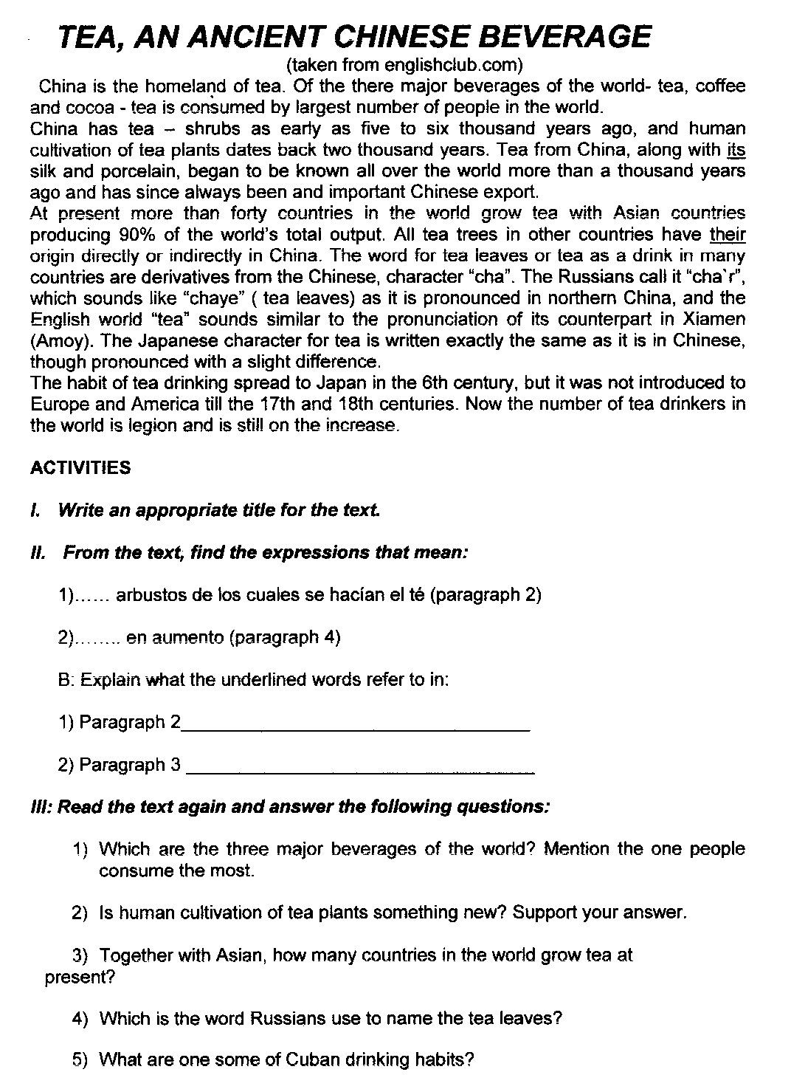

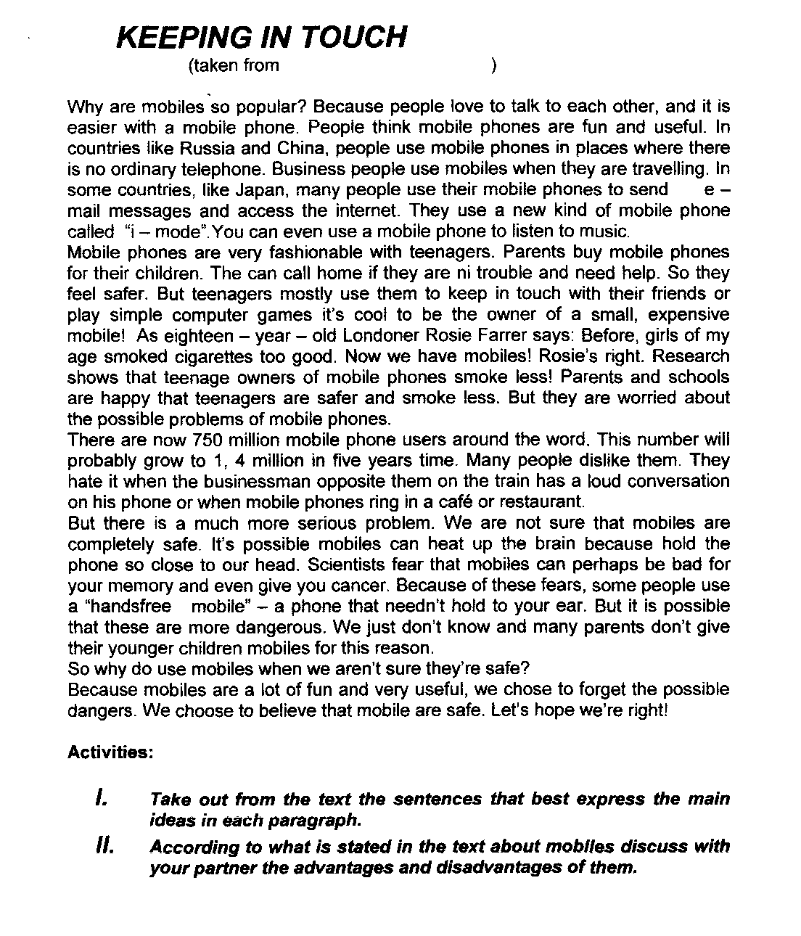



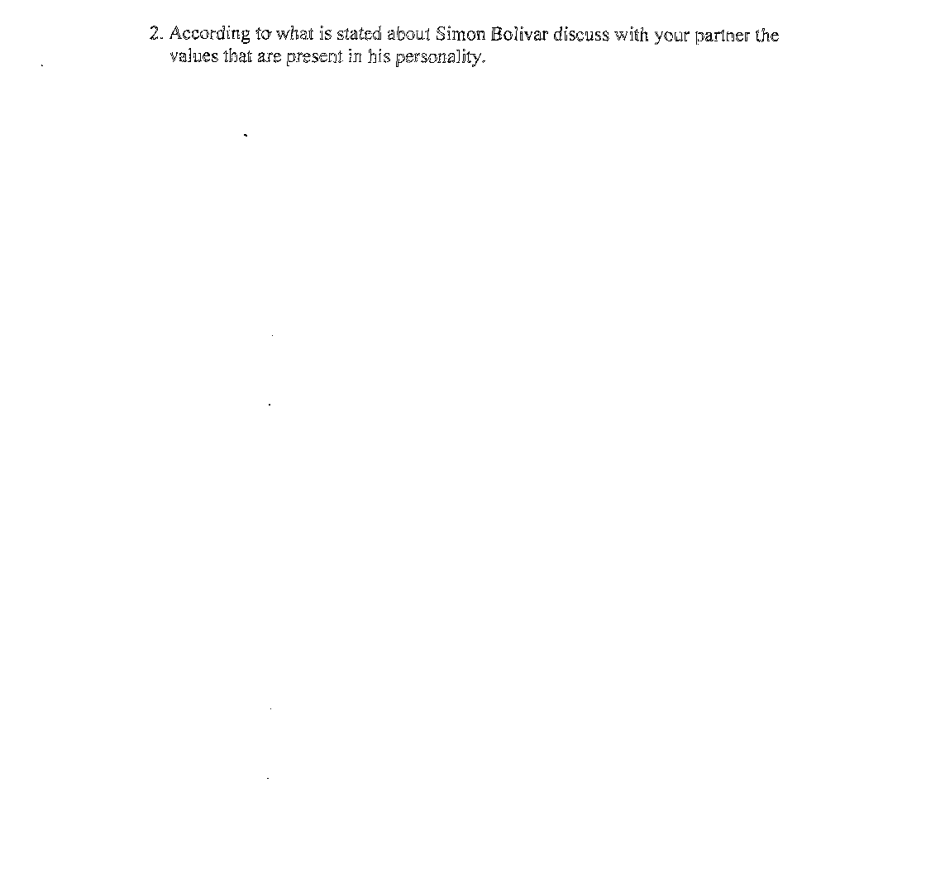

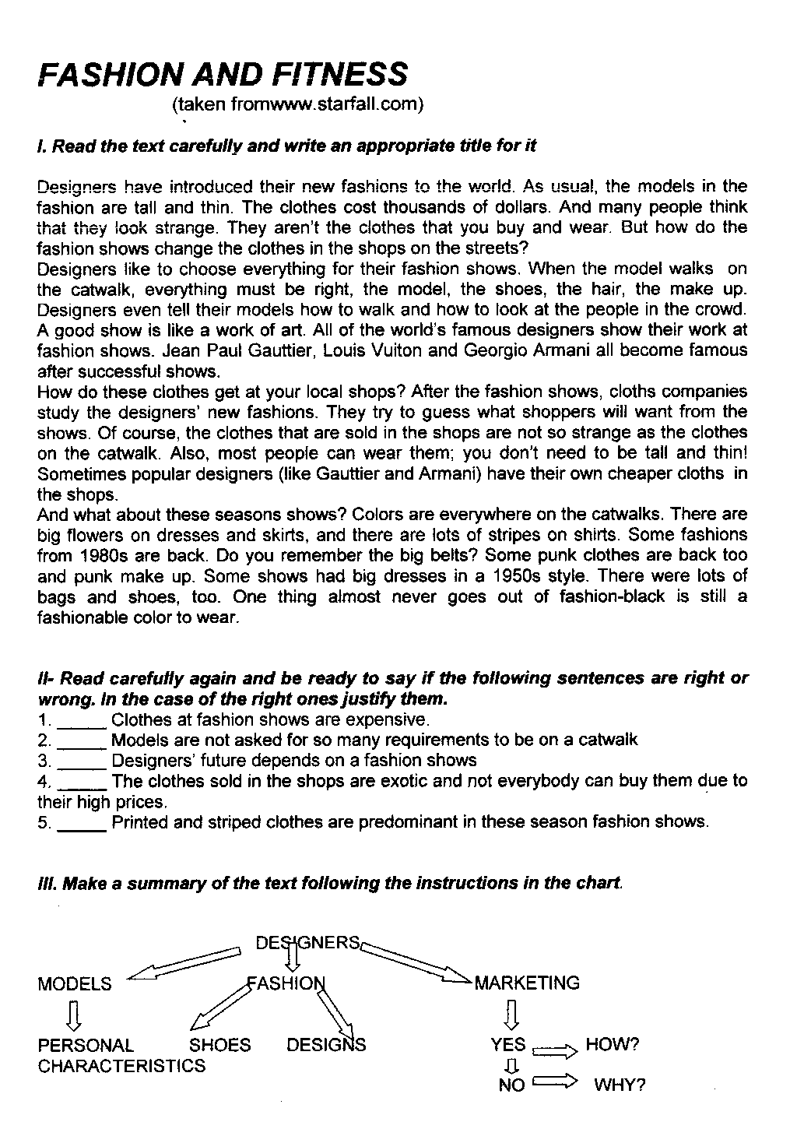

EATING FOR ENERGY
(taken from ww.starfall.com).

I-Read the carefully and speculate about the title. Give as much opinions as you can.
Many professional sports teams have recently added a new member to their organization; a nutrionist.That´s because athletes have become aware that food affects performance.You do not have to be an athlete to notice this effect.If you have never skipped breakfast and then tried to clean the house, you know that you need food for energy. Here are some tips about eating to increase your physical performance.

- Eat enough food. Your body needs a certain number of calories each day. If you are too thin you will feel tiredand you will be more likely to get sick.
- Read the labels of food products.This information the food is.
- Avoid eating food that is high in simple carbohydrate ,that is, sugars.A chocolate bar will first give you energy,but then it will leave you feeling even more tired.
- Eat a balanced diet, one that includes complex carbohydrate, proteins, and fat.Use the food pyramid to help you to decide how much to eat of each type of food.Complex carbohydrates provide the body with “fuel”,They are found in fruits and in vegetables, and in bread, rice, pasta, and other food made from grains.The body uses proteins to build muscles and it uses fat to absorb the vitamins in food.Protein and fat found in foods like milk, cheese, meat, fish and eggs.Too much fat ,however, can be harmful.

II-Match column A and B.

1-Performance can be _____to follow a balanced diet
2-Food is necessary ______ to avoid eating food that is high in sugar.
3-Thin people ______ for energy.
4-Physicians recommend ______ affected by food.
5-To be healthy is important ______will be more likely to get sick

III-Make a summary of the text filling the blanks.

__________ plays an important role in the process of increasing your physical performance.There are some__________ that have specific functions for energy.You have to be careful with_____ because it´s used to absorb the vitamins in food but too much__________ can be dangerous.

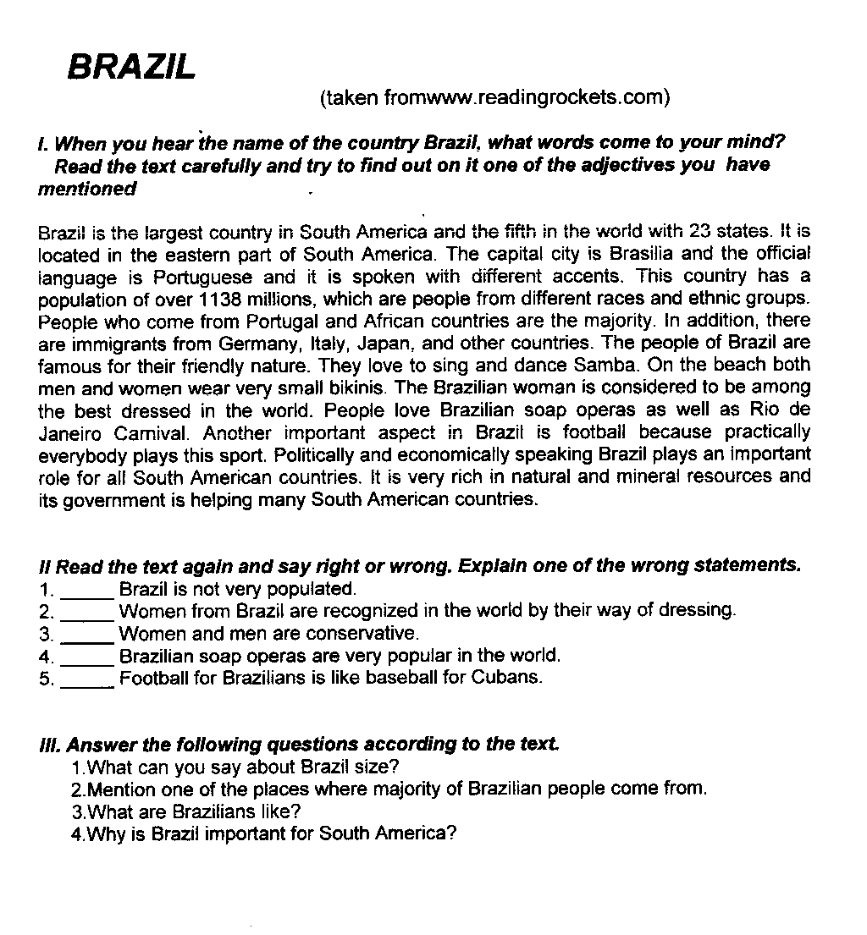

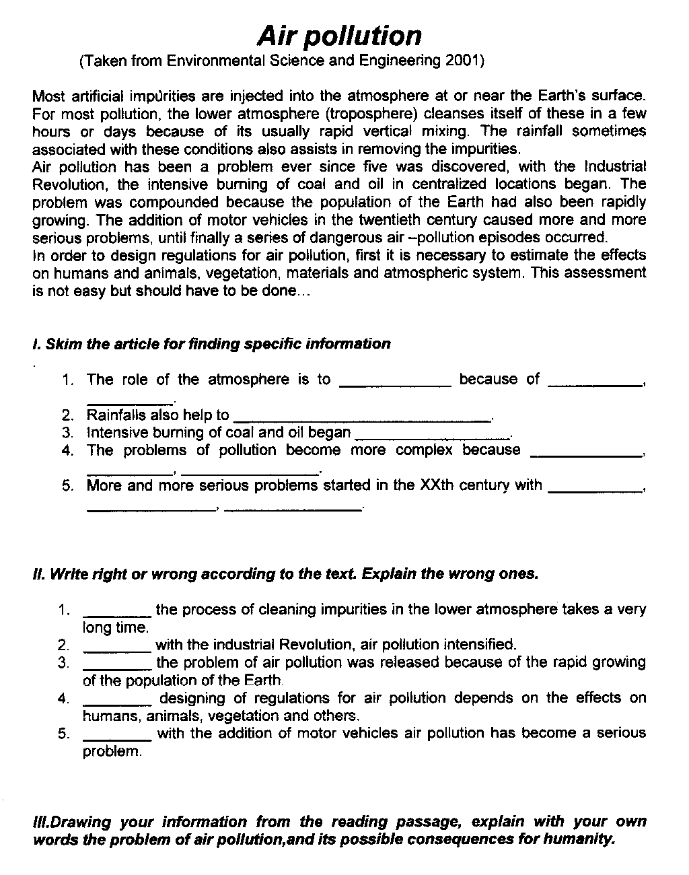

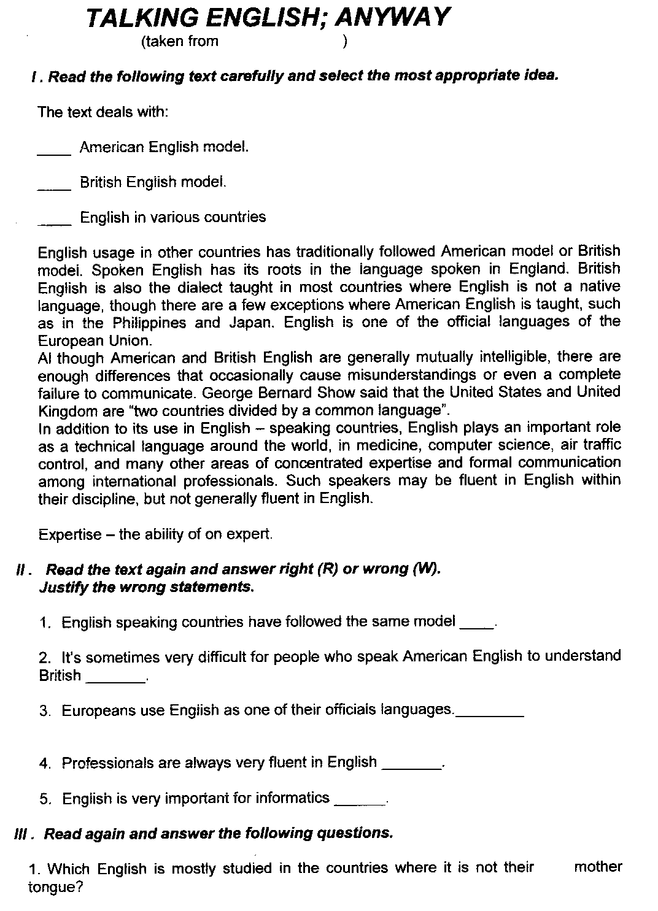

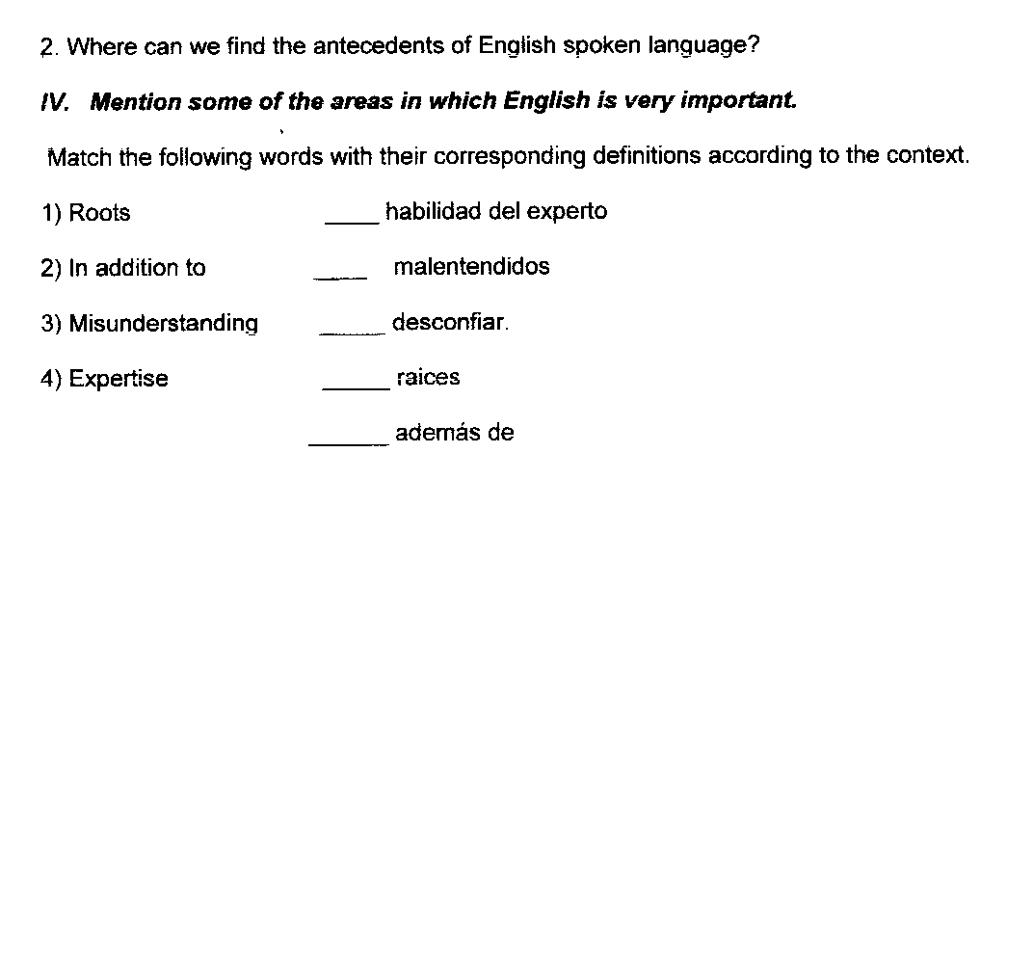

EATING FOR ENERGY
(taken from ww.starfall.com).

I-Read the carefully and speculate about the title. Give as much opinions as you can.
Many professional sports teams have recently added a new member to their organization; a nutrionist.That´s because athletes have become aware that food affects performance.You do not have to be an athlete to notice this effect.If you have never skipped breakfast and then tried to clean the house, you know that you need food for energy. Here are some tips about eating to increase your physical performance.

- Eat enough food. Your body needs a certain number of calories each day. If you are too thin you will feel tiredand you will be more likely to get sick.
- Read the labels of food products.This information the food is.
- Avoid eating food that is high in simple carbohydrate ,that is, sugars.A chocolate bar will first give you energy,but then it will leave you feeling even more tired.
- Eat a balanced diet, one that includes complex carbohydrate, proteins, and fat.Use the food pyramid to help you to decide how much to eat of each type of food.Complex carbohydrates provide the body with “fuel”,They are found in fruits and in vegetables, and in bread, rice, pasta, and other food made from grains.The body uses proteins to build muscles and it uses fat to absorb the vitamins in food.Protein and fat found in foods like milk, cheese, meat, fish and eggs.Too much fat ,however, can be harmful.

II-Match column A and B.

1-Performance can be _____to follow a balanced diet
2-Food is necessary ______ to avoid eating food that is high in sugar.
3-Thin people ______ for energy.
4-Physicians recommend ______ affected by food.
5-To be healthy is important ______will be more likely to get sick

III-Make a summary of the text filling the blanks.

__________ plays an important role in the process of increasing your physical performance.There are some__________ that have specific functions for energy.You have to be careful with_____ because it´s used to absorb the vitamins in food but too much__________ can be dangerous.

